Data tabled used

|  |  |
| --- | --- |
| STOX_ADDRESSES |  |
| STOX_ASSORTMENTS |  |
| STOX_CENTRAL_SETTINGS |  |
| STOX_DEALER_STATS |  |
| STOX_DISCOUNT_MATRIX |  |
| STOX_FINANCIAL_DATA |  |
| STOX_INFO_PAGES |  |
| STOX_LOCAL_SETTINGS |  |
| STOX_ORDER_DETAILS |  |
| STOX_ORDERS |  |
| STOX_PARTS |  |
| STOX_RESERVATIONS |  |
| STOX_SHIPPING_MODES |  |
| STOX_SUPPLIER_SHIPPING_MODES |  |
| STOX_DEALER_EXCLUSIONS |  |
| D2D_ORDERS |  |
| D2D_REQUESTS |  |
| TMP_STOX_RNR | Check if used |
| STOX_PARTS_DELETED | Check if used |
| STOX_DEALER_STATS_ARCHIVE | Check if used |

Data Model design

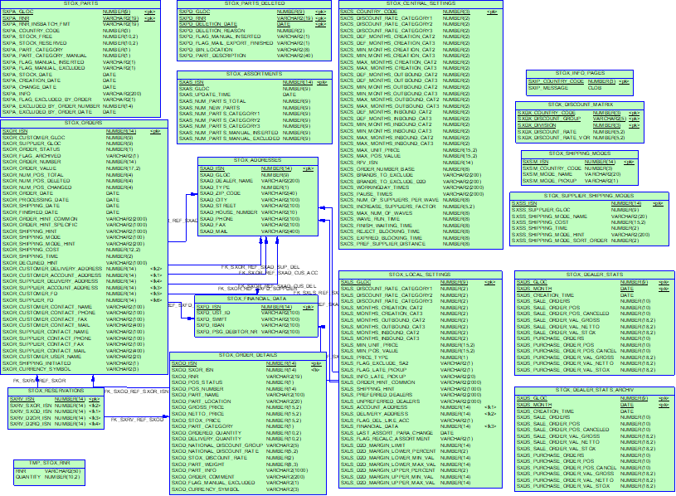

Common search

STOX_LOCAL_SETTINGS

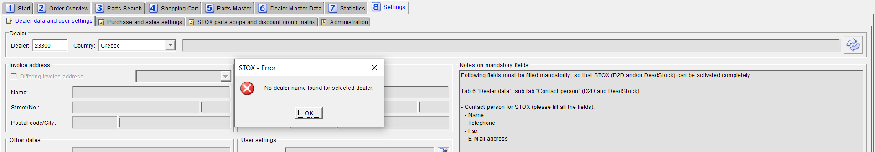

Operating data and user settings

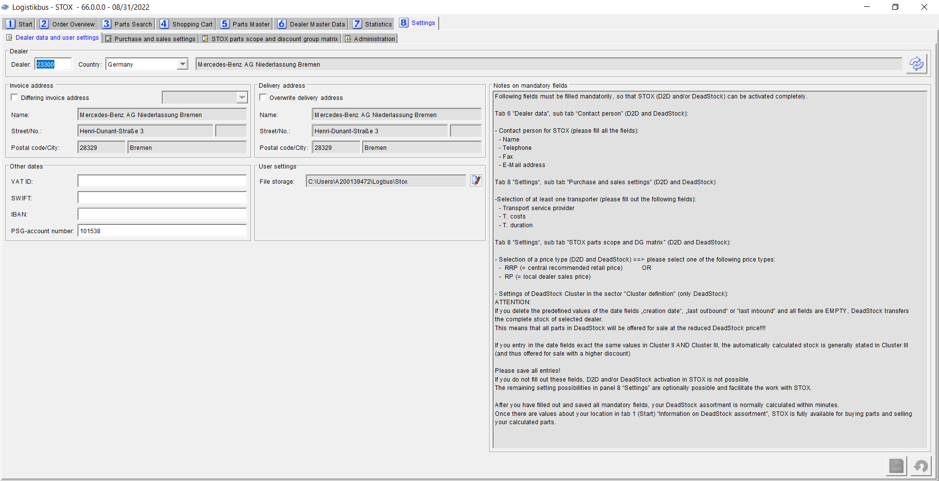

SxDealerDataPanel.java

SxDealerDataModel.java

StoxLocalSettings.java

Table name - STOX_LOCAL_SETTINGS

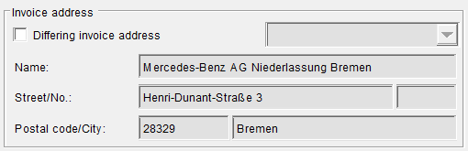

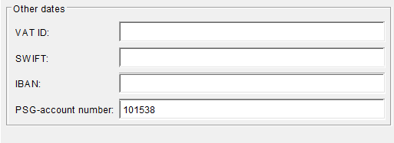

Table used – STOX_FINANCIAL_DATA

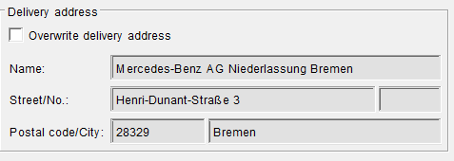

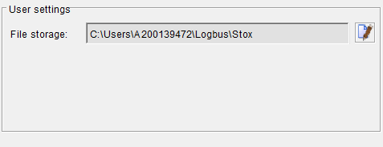

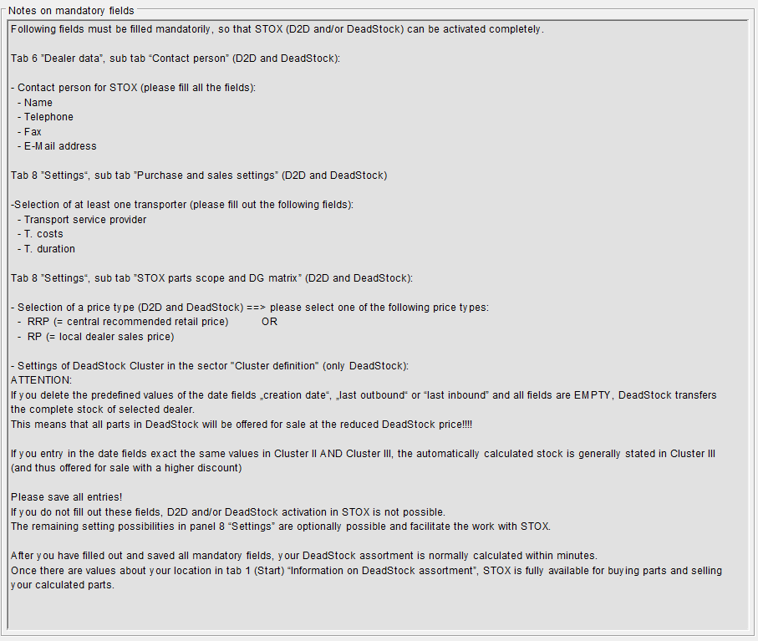

Buy and sell settings

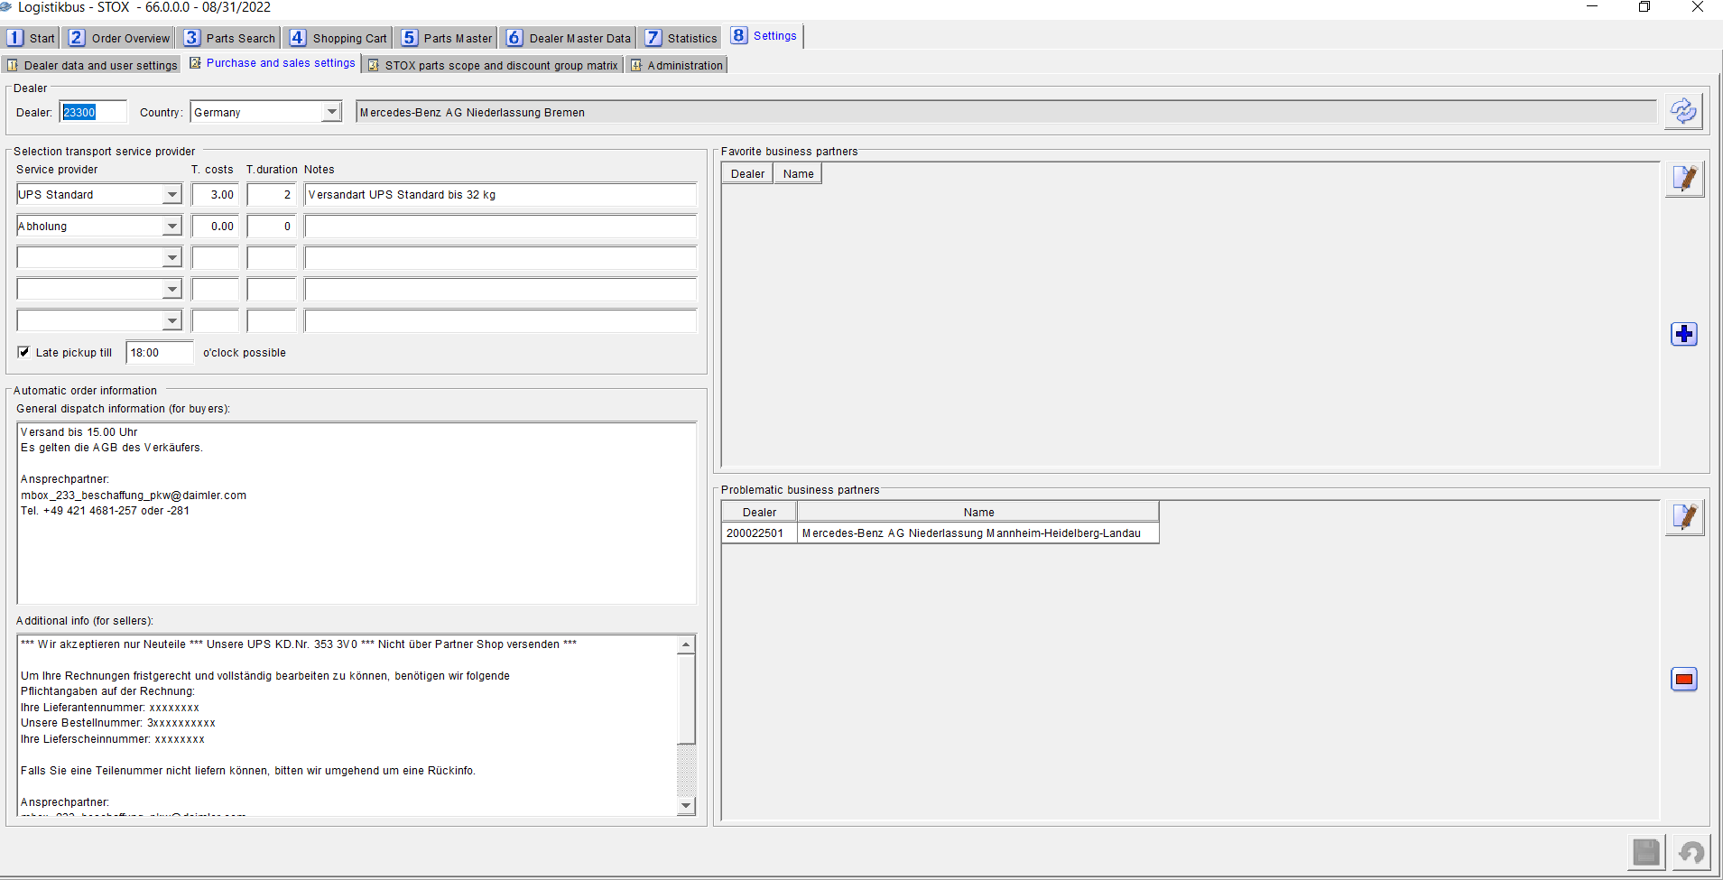

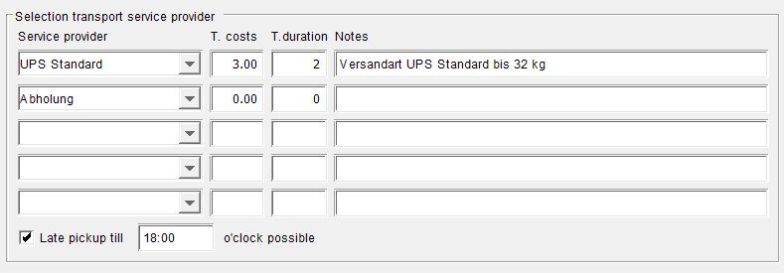

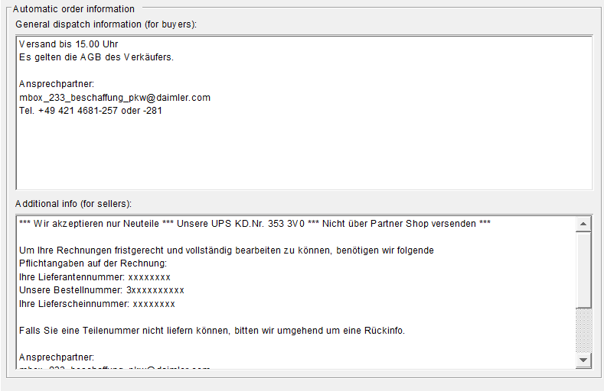

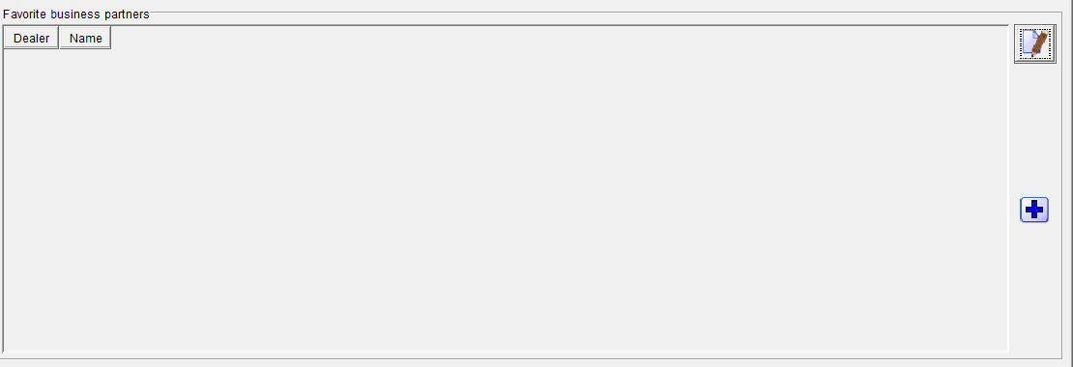

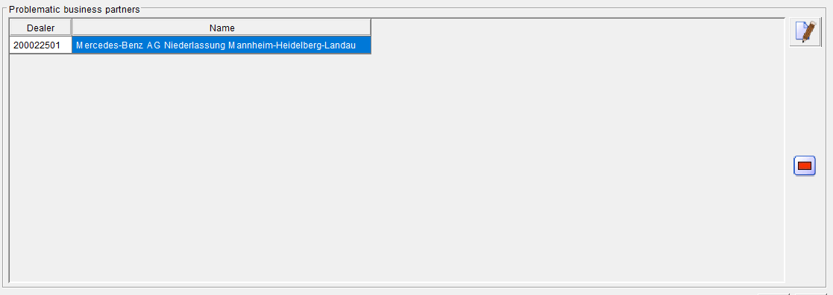

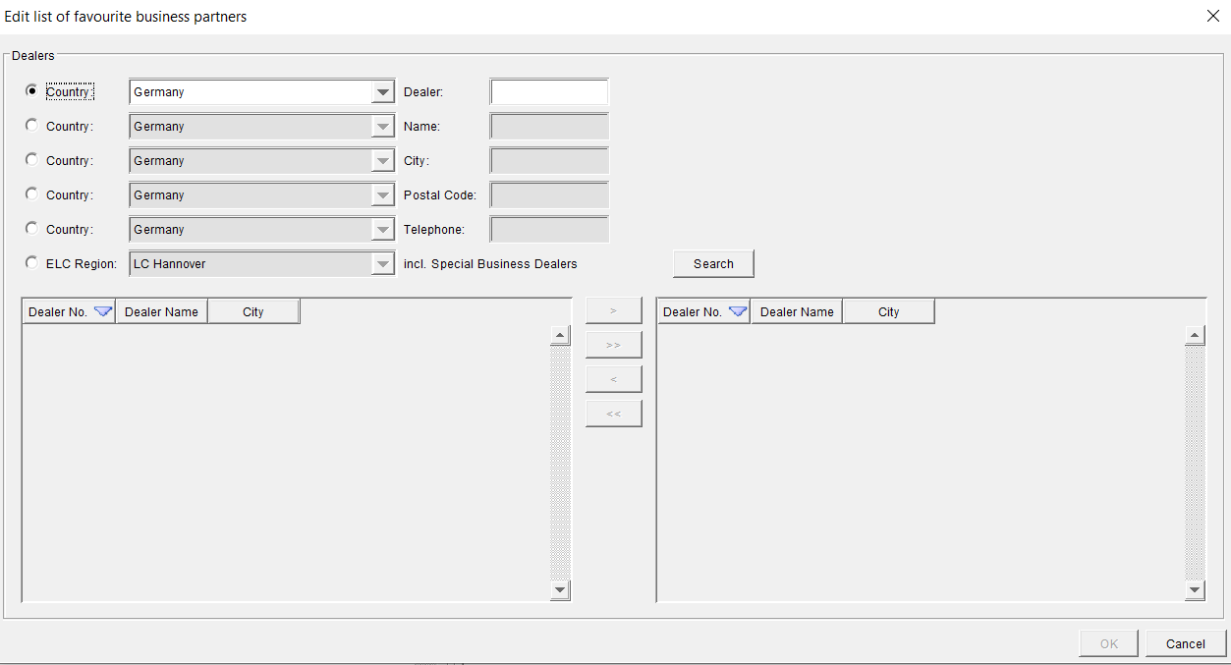

STOX Part Scope and RG Matrix

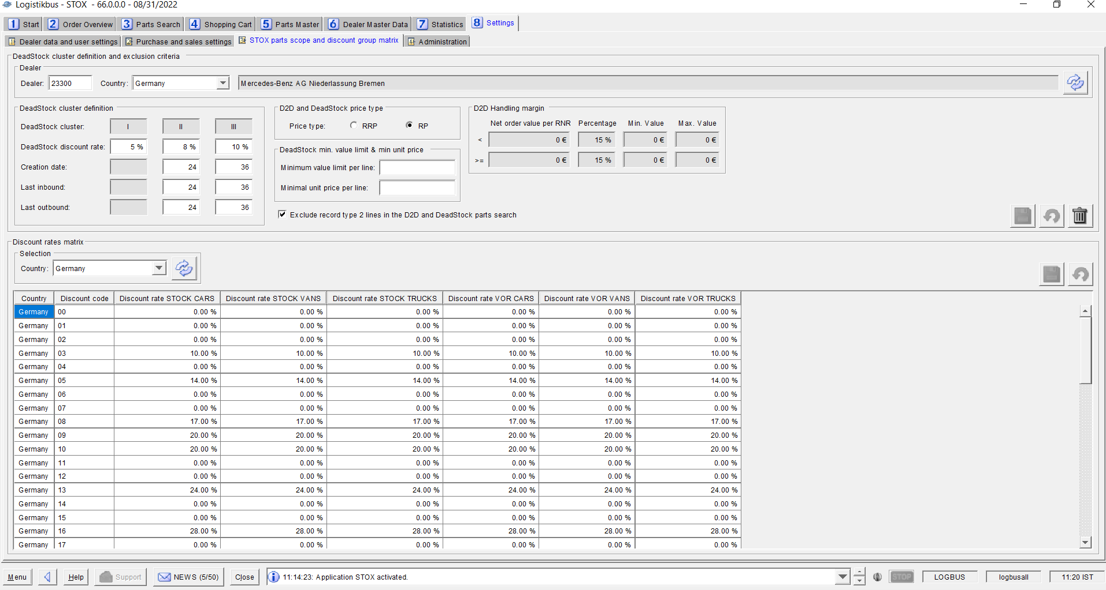

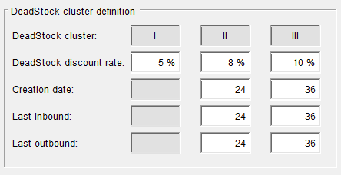

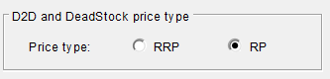

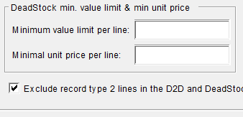

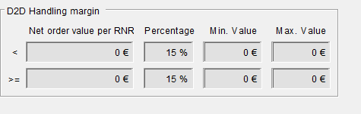

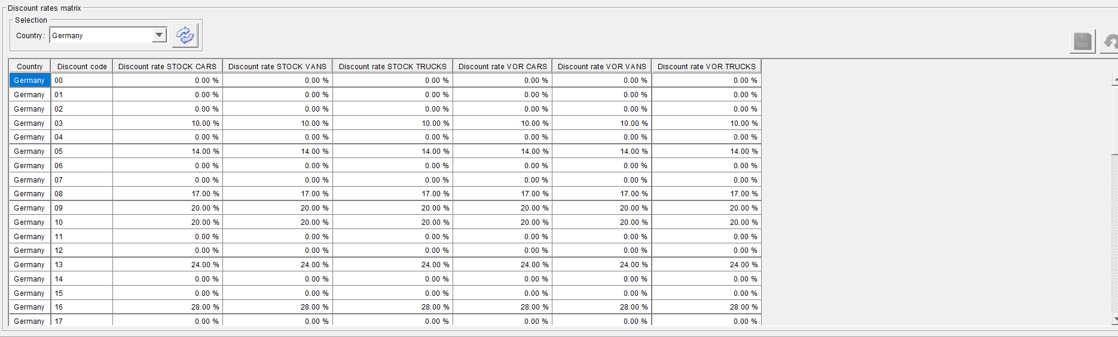

Administration

